CS110 Project

Type the Color Not the Word

Uttsow Rahman & Dean Spector

This fun game has the user work to differentiate between the color and word presented. This game introduces you to your mind’s rapid re-implementation of strategies to identify the color of the words under time constraint. One technique might include attempting not to read the words themselves so the colors remain, alone, evident. Another method involves acknowledging the word as fast as possible, so all that is left is to look at the actual color. One can attempt to learn how their own mind reacts to such—seemingly confusing—stimuli, and even hope to discover the implications of such reactions.

Welcome Screen:

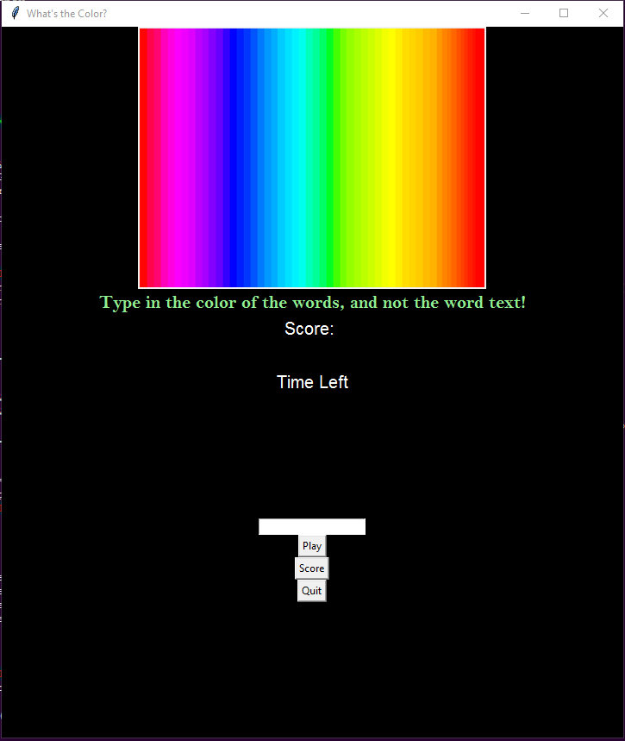

When the user selects the play button, she is presented with the first color/word and must work to type the color into text box. When the input is \*entered\*, she is presented with a different color/word.

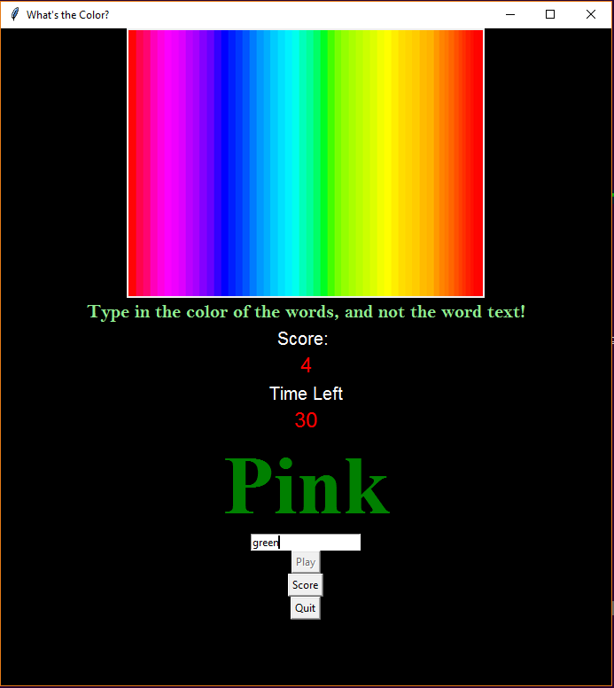

Within the minute allotted, the number of correct submissions correspond to a score. One can also select the \*Score\* button to view the score as well.

